

HITEC University, Taxila
BS Cyber Security 3rd Semester
Fall 2025

Lab Report # 11

Subject: Artificial Intelligence

Submitted By: Abdul Majid (24-CYS-021)
Muhammad Usama(24-CYS-013)

Section: B

Submitted To: Mr Mubahsir Iqbal

BS Cyber Security Program Department of Computer Science HITEC UNIVERSITY, TAXILA

Task no 01:
Predict Canada's per capita income in the year 2020 using the canada_per_capita_income.csv file. Using this, build a regression model and predict the per capita income of Canadian citizens in the year 2020.

Code:
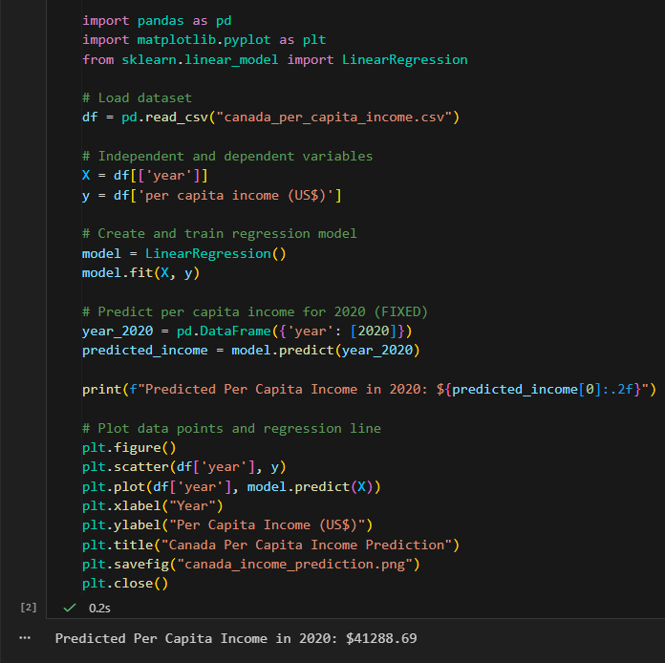

Task no 02:
Using the below dataset, build a logistic regression model to predict whether a customer
will purchase a product or not (Purchased) based on the features Age, Gender,
Annual_Income, and Browsing_Time. Perform the following tasks:
1. Preprocess the data (e.g., convert Gender to numerical).
2. Split the data into features (X) and target (y).
3. Fit a logistic regression model using scikit-learn.
4. Predict the purchase status for the new sample data.
5. Evaluate the model using the accuracy score.

Code:
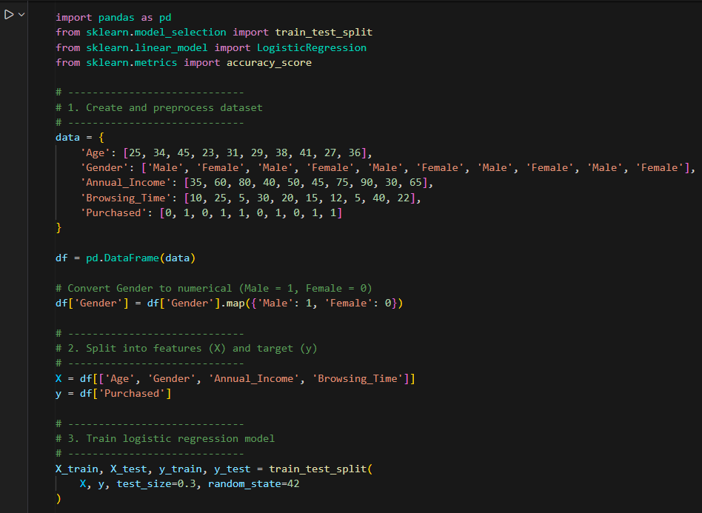
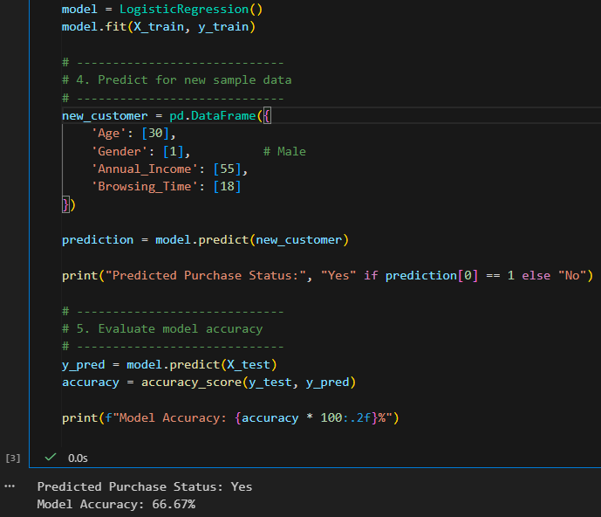

Conclusion:
In this lab, we implemented predictive models using Python and scikit-learn. In Task 1, linear regression was applied to historical data to predict Canada’s per capita income, successfully estimating the value for 2020 and illustrating the linear relationship between year and income. In Task 2, logistic regression was used to predict customer purchase behavior based on age, gender, annual income, and browsing time, with categorical data properly encoded and the model evaluated for accuracy on test data. The lab demonstrated how regression techniques can be effectively used for both continuous and binary outcomes, emphasizing the importance of data preprocessing, model training, prediction, and evaluation in practical predictive analytics.

